Kickstart Summary

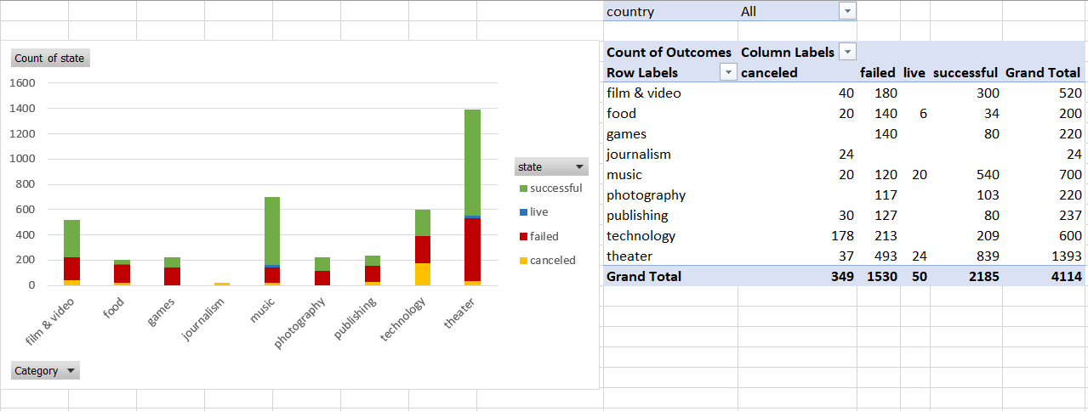

**Finding one**: Theater, Film & Video, and Music categories seem to have the most success

**Finding two**: Despite a lot of technology activity the category is only ~30 - 35% successful

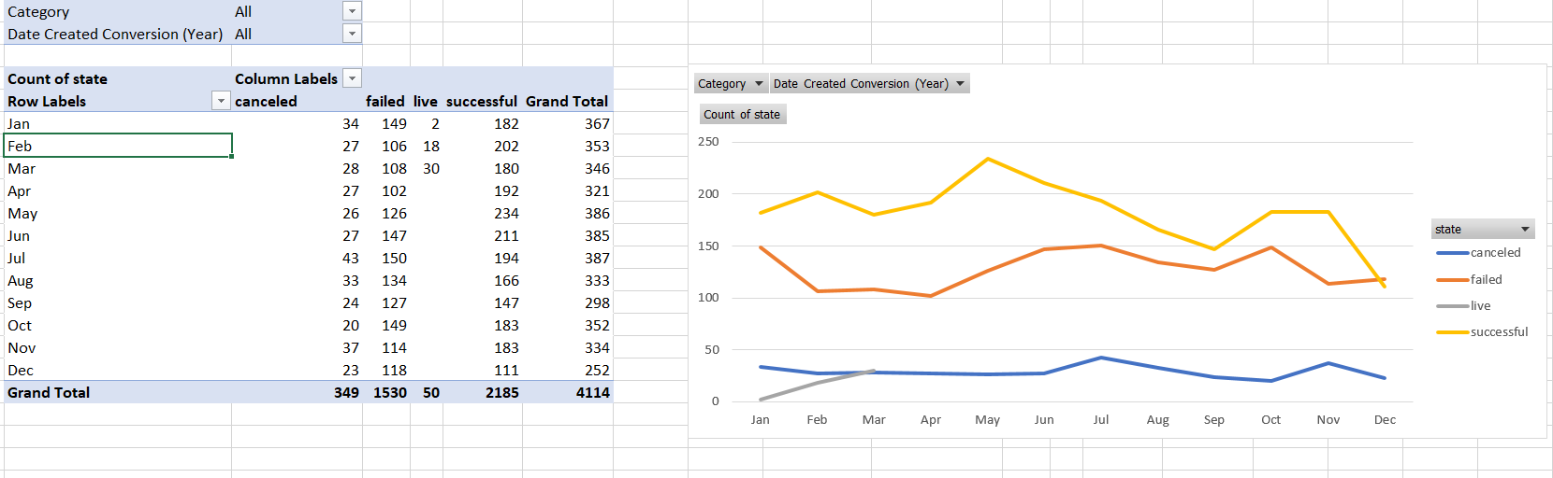

Finding three: There is a significant drop off in activity across the board in December.

**Limitations of the dataset**: The financials are various currencies making it hard to compare apples to apples. I tried to offset this limitation by creating a currency conversion table. It would eb good to have better context around these projects. The expertise and reputation for the project/startup leads and broader team. This would influence funding success as well and project delivery after funding. Without this kind of information, we would not know what is driving the success or failures.

Since the measures of central tendency is quite limited in representing the data, we may want to do further analysis using interquartile range. The variance in the data is significant limiting the central tendency measures. Rerunning the analysis after dropping outliers could be more informative, if the goal is to garner insights rather than just to illustrate what happened.